13.48_X---------------------------------------------------------------------------
[1] res free# JVEMV6 44#13.51.1_X / 44. currency / 13. tasks / 51. observe / 1. specific-selections:prev 4 bars ==> all up/down / 20201013_180907 + 20201016_113448

[do] #_
- REVIEW
- TASK-1 : prev-4 bars ==> up
    - target ==> [ea-4_tester-1].(20200915_045322).(tickets-data).log
    - file : log_JVE_44_6_2.[session-26~].ods / sheet : 1
C:\WORKS_2\WS\WS_Others.JVEMV6\JVEMV6\44_currency\10_prog-php\2_tester\log_JVE_44_6_2.[session-26~].ods
statement
C:\Users\iwabuchiken\AppData\Roaming\MetaQuotes\Terminal\34B08C83A5AAE27A4079DE708E60511E\MQL4\Files\Logs\#20200915_045322[eap-2.id-1].[AUDJPY-5].dir\DetailedStatement.[m5].[20200921_154212].htm
log file
C:\WORKS_2\WS\WS_Others.JVEMV6\JVEMV6\44_currency\10_prog-php\2_tester\tasks_[51.1].odt
    - #20201013_181447
  - T-1.1
    - -590 :
2020.09.15 13:30:00 / 2020.09.15 14:00:41 / 0.022 / 28487831
2 3 3 3 3 4 3 4 4 4 4 4
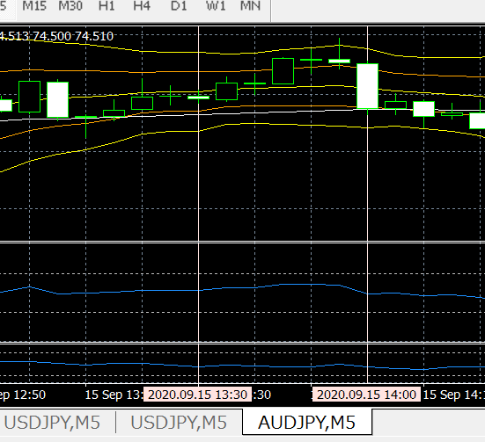
- 経緯
  - prev-4 bars ==> up
  - yet, prev-1 ==> “cross”
  - prev-4 ==> + 3.0 pips
- 経過
  - prev-4 bars は、連上げだが、弱い上げ。
  - 爾後、連上げ４本続いた。
  - しかし、BB-loc.2 のところで、下げ、始まる。
  - trailing は始まっていた。よって、+0.02 pips のところで、trail-SL
- prev 12 vars (sketch-id=SCXV)
  - ==> see memo

13.48_1---------------------------------------------------------------------------
[2] res free# JVEMV6 44#13.51.1_X / 44. currency / 13. tasks / 51. observe / 1. specific-selections:prev 4 bars ==> all up/down / 20201017_143639

- T-1.1
  - sort : DW > DF
  - #20201017_144321
  - col names
  - graph
  - OBS
2020.09.16 12:45:01 / 2020.09.16 13:32:17 / -630 / 28504694
3 4 4 5 5 5 5 4 3 3 2 1
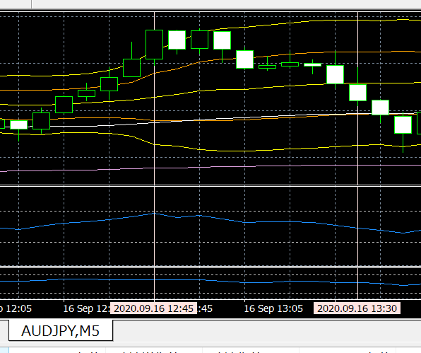
- 経緯 #ref:WZ2E
  - prev 5 bars → up / BB.loc-5 ==> loc-1 / +9 pips
  - prev 4 bars ==> +6.8 pips
  - prev 4 bars
    - up : 4 → 1
    - dif : 77.072 ~ .141 : + 6.9 pips
  - RSI, MFI
    - prev-1 : 62.4789 / 64.4779
    - prev-4 : 54.8786 / 65.1539
    - dif : 7.6003 ( + 13.84 % ) / - 0.676 ( - 1.037 % )
  - prev 5 ~
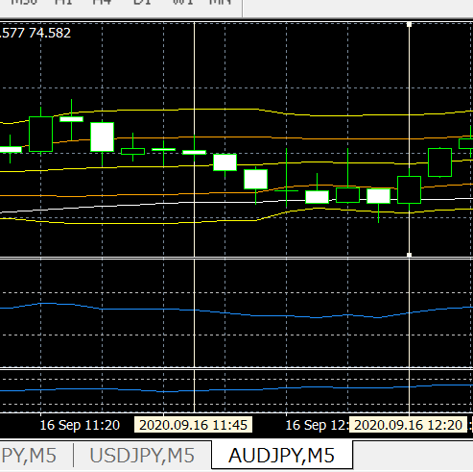
    - 5 ~ 9 : box ( dif =~ 2.2 pips / loc = 5 - 4 )
    - 10 ~ 16 :
      - serial-down : 2 → 4, dif = .118 ~ .062 ( - 5.6 pips)
      - pop-1 : prev-14, 4 pips
- 経過
  - 次のバーから、下がり始める。
- 2020.09.16 12:50:09 / 2020.09.16 13:09:46 / -550 / 28504836
3 4 4 5 5 5 5 4 3 3 2 1
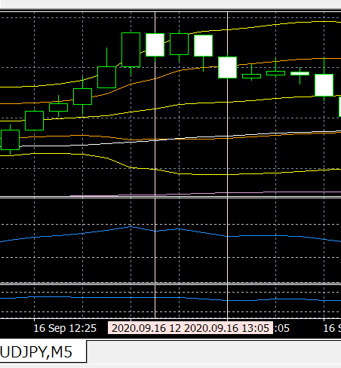
- 経過
  - prev 6 bars → up / BB.loc-5 ==> loc-1 / + 12.6 pips
  - prev 4 bars ==> + 8.5 pips (77.093 ~ .178)
  - 8.5 / 12.6 ==> 67.4 %
- 経緯
  - + 3, +4 本目 => 連下げ => SL
- 2020.09.16 12:40:01 / 2020.09.16 13:09:45 / 20 / 28504603
3 3 4 4 5 5 5 5 4 3 3 2
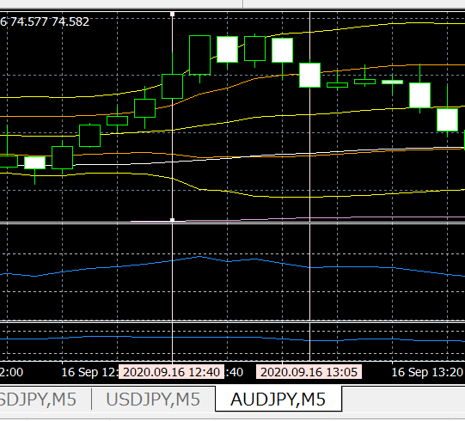
- 経過
  - prev 4 bars → up / BB.loc-5 ==> loc-2
  - prev 4 bars ==> + 6.6 pips (77.051 ~ .117)
  - prev-1
    - RSI → 58.8996 / MFI → 64.5819
  - prev-4
    - RSI = 53.9450 / MFI = 52.9276
  - prev-1 のclose は、bb.loc-2
- 経緯
  - post-1 で、さらに上げ。これで、trail start か。
  - post-5 で、trail-SL

13.48_2---------------------------------------------------------------------------
[3] res free# JVEMV6 44#13.51.1_X / 44. currency / 13. tasks / 51. observe / 1. specific-selections:prev 4 bars ==> all up/down / 20201018_151851

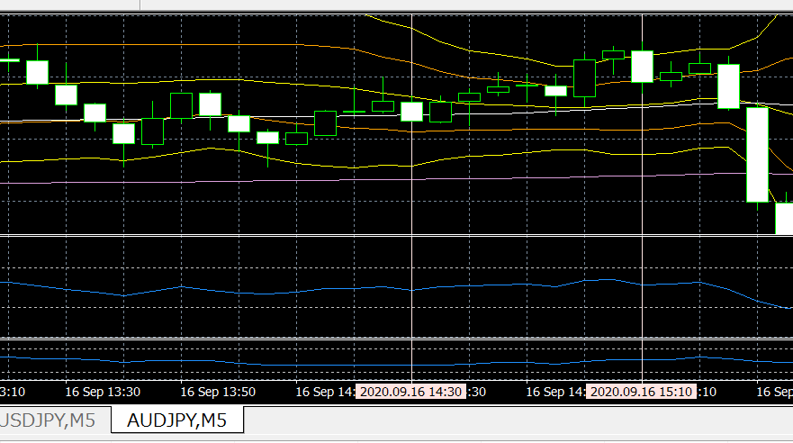
2020.09.16 14:30:01 / 2020.09.16 15:13:41 / 40 / 28506319
4 5 5 4 4 5 5 5 5 4 4 4
- 経緯
  - prev 4 bars
    - up : 5 → 2
    - 77.045 ~ .091 : + 4.6 pips
  - RSI, MFI
    - prev-1 : 50.6130 / 38.6450
    - prev-4 : 45.1735 / 39.0336
    - dif : 5.4395 ( + 12.04 % ) / - 0.3886 ( - 1.0 % )
  - prev 5 ~
    - 5 ~ 9 ==> mountain
    - 10 ~ 14 ==> serial-down
- 経過
  - post-7 ==> highest
  - post-8 ==> trail-SL

2. review ==> #ref:WZ2E ==> OK

@@@

============================== TEMPLATE / 20200904_113804

/ ============================== TEMPLATE / 20200904_113804

original : C:\WORKS_2\WS\WS_Others.JVEMV6\JVEMV6\44_currency\10_prog-php\2_tester\log_20200520_160805.[fx_TASKS-26_move-statement-files-from-note-pc-to-desktop].odt ]20200825_170811

